Nepal College of Information Technology
Unit Test
Fall 2009

Program: ELX Time: 2 hrs
Semester: Fall FM: 50
Subject: EMFW PM:
Attempt ALL the questions. . Figures at the margin indicate their full marks.
1. Give the physical significance of divergence of a vector with necessary derivation. State and prove the Divergence theorem. [10]
2. Express the following vectors in Cartesian coordinates
(i)
(ii) 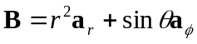 [5*2]
3. If 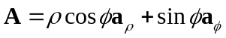, evaluate 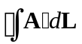around the path shown in figure 1.
[10]
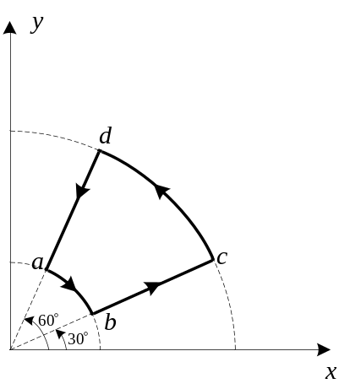
Figure 1
4. Given the scalar field 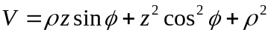and vector field 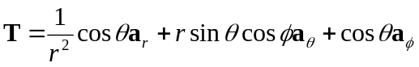. Determine the gradient of V and the curl of T. [10]
5. State Coulomb’s law. Use it to derive the electric field due to a finite uniformly charged conductor with charge density ρ_{L} C/m. Also find the electric field due to an infinitely long line charge placed anywhere. Interpret your result. [10]
6. The circular region ρ ≤ a, z = 0, carries a uniform surface charge density ρ_{S} C/m². Find E at P(0, 0, h), h > 0. [10]
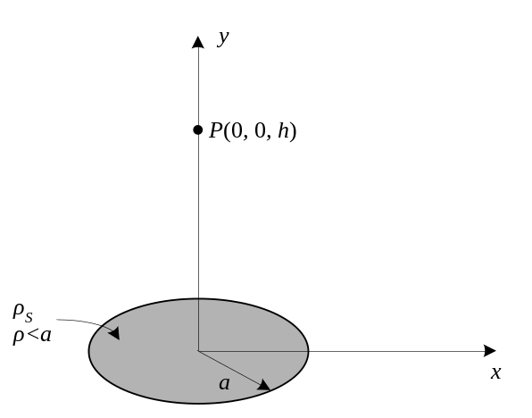
7. Find the electric field due to a uniformly charged sphere with radius a and charge density ρ_{v} at any point P inside and outside the sphere. Roughly plot E vs r, where r is the radial distance of P from the center of the sphere. [10]
8. Derive Maxwell’s first equation. Given the electric flux density C/m². Find the charge density, ρ_{v} at P(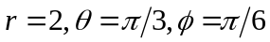). [10]
9. Write short notes on(Any two) [10*2]
(a) Spherical co-ordinate system
(b) Electric Potential due to a point charge.
(c) Gauss Law

